**Bash Scripting**

**Naman Moolri CEQ-525**

**Introduction**

A **bash script** is a file containing a sequence of commands that are executed by the bash program line by line. It allows you to perform a series of actions, such as navigating to a specific directory, creating a folder, and launching a process using the command line.

By saving these commands in a script, you can repeat the same sequence of steps multiple times and execute them by running the script.

**Advantages**

Bash scripting is a powerful and versatile tool for automating system administration tasks, managing system resources, and performing other routine tasks in Unix/Linux systems.

**Some advantages of shell scripting are:**

**Automation:** Shell scripts allow you to automate repetitive tasks and processes, saving time and reducing the risk of errors that can occur with manual execution.

**Portability:** Shell scripts can be run on various platforms and operating systems, including Unix, Linux, macOS, and even Windows using emulators or virtual machines.

**Flexibility:** Shell scripts are highly customizable and can be easily modified to suit specific requirements. They can also be combined with other programming languages or utilities to create more powerful scripts.

**Accessibility:** Shell scripts are easy to write and don't require any special tools or software. They can be edited using any text editor, and most operating systems have a built-in shell interpreter.

**Integration:** Shell scripts can be integrated with other tools and applications, such as databases, web servers, and cloud services, allowing for more complex automation and system management tasks.

**Debugging:** Shell scripts are easy to debug, and most shells have built-in debugging and error-reporting tools that can help identify and fix issues quickly.

**Overview of Bash shell and command line interface**

The terms **"shell"** and **"bash"** are used interchangeably. But there is a subtle difference between the two.

The term **"shell"** refers to a program that provides a command-line interface for interacting with an operating system. **Bash (Bourne-Again Shell)** is one of the most used Unix/Linux shells and is the default shell in many Linux distributions.

**Steps on how to create a simple Calculator.**

1. **Create an Ubuntu instance using AWS. (We can use our Gitbash also but there are some commands that only runs on Ubuntu)**
2. **Now, create a file where you will perform the task.**

**Commands - vi filename**

**(vi - is used for creating a file)**

1. **When file is opened, then first write #! /bin/bash**

**(This is used to specify the path where we must run the file.)**

1. **Write your Bash Code.**

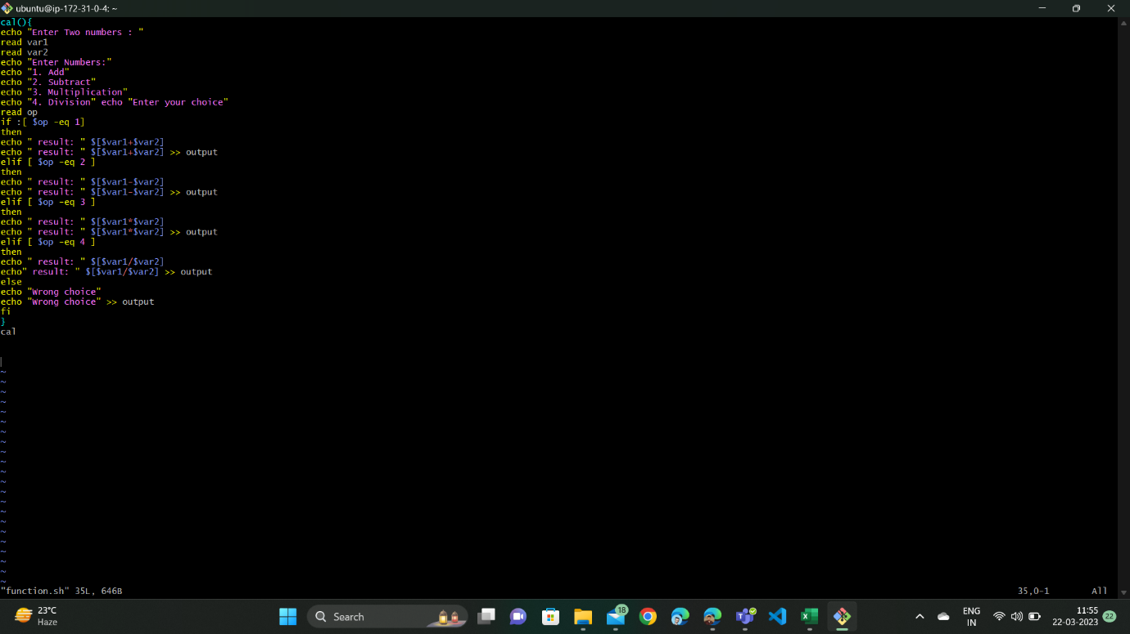

1. **Now, save it using Esc + S keys.**
2. **Exit the file using Esc + :wq! keys.**

**(If it shows permission denied, then use chmod 777 file that is used for changing the permission).**

1. **After that run the file again.**

